St. Bartholomew’s Seniors News
October 2014 | Vol. 1 No. 1

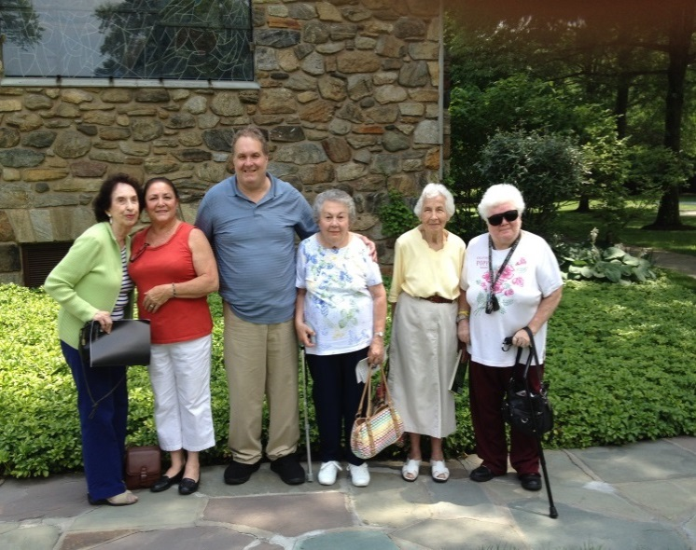 |  | WELCOME  I want to tell you about a group that is growing in St. Bartholomew’s, “the Seniors”. There is no age requirement, only that you have had a “senior moment”, and you are not required to show up every month. We meet after the 9 o’clock Mass, after receiving a special blessing.  Since we started in May 2013, the gathering has been held in the McManus Parish Center, on the first Thursday of each month. We enjoy an informal breakfast of juice, coffee, pastries, and fruit, chatting and getting to know one another.  Sometimes we view a DVD, like a segment of Father Robert Barron’s Catholicism series, and end up discussing the ideas. We have gone to a movie theater as a group to see The Son of God. More recently we read the book Heaven is for Real, saw the movie together at a movie theater, explored the Catechism of the Catholic Church discussion of Heaven, Purgatory, and Hell, and then had three lively discussions. We have played board games which are a fun way to learn more about our Faith.  Lively discussions also followed reading the book and viewing the DVD of the popular The Five People You Meet In Heaven as well as reading about the life of St. Josephine Bakhita and viewing the Saint Bakhita – From Slave to Saint DVD.  Perhaps you have been interested in the architecture of The Riverside Church in NYC. We took a guided tour there recently. Of, if your interest is art, you could have come with us to see the beautiful Marc Chagall and Henri Matisse windows in the Union Church in Pocantico Hills.  We’re about to read a book, watch a DVD, and discuss the life of St. Rita of Cascia. A tour of the Cathedral Church of St. John the Divine in Manhattan is also in the works. And, at Christmastime we’re planning to again view the beautiful Nativity scene, Presepio, at the Westchester Italian Cultural Center in Tuckahoe.  So, why not join us at Mass and head over to the McManus Parish Center for the next meeting? The coffee and the company are great!  Ruth Sweeney
Marie Giuriceo, Grace Obalde, Mark Cianfaglione, Grace Prunella, Ruth Sweeney and Audrey Falcone at Union Church of Pocantico Hills on July 3, 2014
Senior Testimonial

I heard of the monthly Seniors Mass & Gathering during the announcements for months and, over the summer, my curiosity kicked in. I didn’t know who attended or how many members there were in the group. So, I went to Mass and then for coffee. I saw a few people I knew and a couple more people I did not, but each one had a smile and a kind word of welcome. Afterwards, a smaller group was going to tour Union Church. I was invited to go and joined them. There was beautiful artwork in the windows designed by Matisse and Chagall, with stories about each window told to us by the docent.

The absolute highlight of my time with the group was reading a small biography and viewing the movie on the life of St. Bakhita. It was extremely enlightening to see how God’s love and mercy changed so many through this beautiful soul. When I think of her I am filled with emotion and feel so humbled to know of her.

I am honored and feel privileged to be part of this “band”. I have added to the people I have known in the 45 years that I have been part of St. Bart’s family, and all the more blessed for it.

Grace Obalde
Follow the St. Bartholomew’s Seniors at: http://adult-faith-formation.weebly.com/senior-group.html

